**PRACTICAL-2**

**AIM: [Write a Servlet which prints a greeting message on Browser.]**

**PROGRAM:**

/*

* To change this license header, choose License Headers in Project Properties.

* To change this template file, choose Tools | Templates

* and open the template in the editor.

*/

import java.io.IOException;

import java.io.PrintWriter;

import javax.servlet.ServletException;

import javax.servlet.http.HttpServlet;

import javax.servlet.http.HttpServletRequest;

import javax.servlet.http.HttpServletResponse;

/**

*

* @author kashy

*/

public class NewServlet extends HttpServlet {

/**

* Processes requests for both HTTP <code>GET</code> and <code>POST</code>

* methods.

*

* @param request servlet request

* @param response servlet response

* @throws ServletException if a servlet-specific error occurs

* @throws IOException if an I/O error occurs

*/

protected void processRequest(HttpServletRequest request, HttpServletResponse response)

throws ServletException, IOException {

response.setContentType("text/html;charset=UTF-8");

try (PrintWriter out = response.getWriter()) {

/* TODO output your page here. You may use following sample code. */

out.println("<!DOCTYPE html>");

out.println("<html>");

out.println("<head>");

out.println("<title>Servlet NewServlet</title>");

out.println("</head>");

out.println("<body>");

out.println("<h1>Welcome to Servlet!"+"</h1>");

out.println("</body>");

out.println("</html>");

}

}

// <editor-fold defaultstate="collapsed" desc="HttpServlet methods. Click on the + sign on the left to edit the code.">

/**

* Handles the HTTP <code>GET</code> method.

*

* @param request servlet request

* @param response servlet response

* @throws ServletException if a servlet-specific error occurs

* @throws IOException if an I/O error occurs

*/

@Override

protected void doGet(HttpServletRequest request, HttpServletResponse response)

throws ServletException, IOException {

processRequest(request, response);

}

/**

* Handles the HTTP <code>POST</code> method.

*

* @param request servlet request

* @param response servlet response

* @throws ServletException if a servlet-specific error occurs

* @throws IOException if an I/O error occurs

*/

@Override

protected void doPost(HttpServletRequest request, HttpServletResponse response)

throws ServletException, IOException {

processRequest(request, response);

}

/**

* Returns a short description of the servlet.

*

* @return a String containing servlet description

*/

@Override

public String getServletInfo() {

return "Short description";

}// </editor-fold>

}

**OUTPUT:**

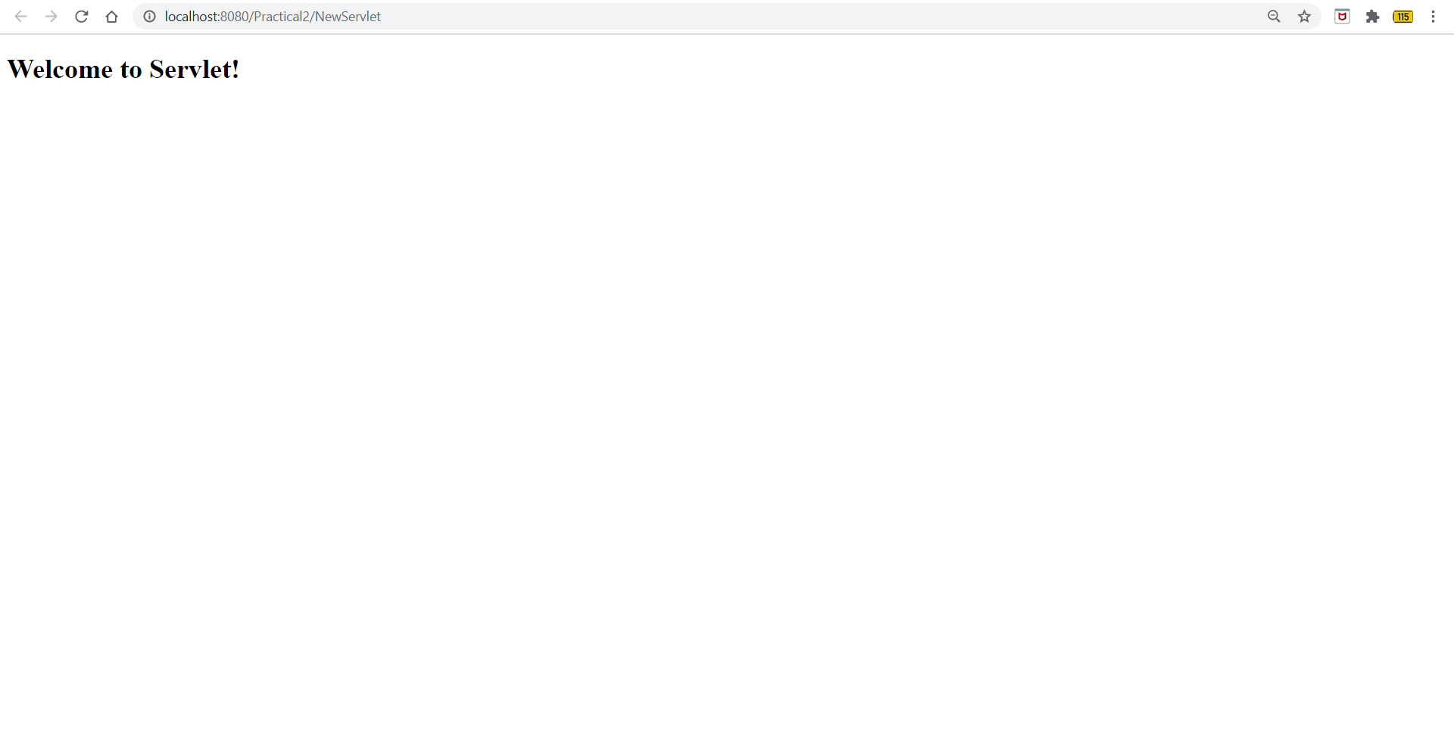

**CONCLUSION:**

In this practical we learnt how to develop a simple WebApplication project & write a Servlet which prints a greeting message on Browser.